**CP Club 365Days Challenge**

**Date – 04/12/2022**

**Programming language – C++**

**Problem Statement**

[https://practice.geeksforgeeks.org/problems/maximize-toys0331/1?page=1&category[]=Greedy&sortBy=submissions](https://practice.geeksforgeeks.org/problems/maximize-toys0331/1?page=1&category%5b%5d=Greedy&sortBy=submissions)

**Your Code**:

// 0x48Day of 0x365Days challenge

// VEDANT BHARAD

// 04-12-2022

//{ Driver Code Starts

//Initial Template for C++

#include <bits/stdc++.h>

using namespace std;

// } Driver Code Ends

//User function Template for C++

class Solution{

public:

    int toyCount(int N, int K, vector<int> arr)

    {

        int con=0;

        sort(arr.begin(), arr.end());

        for(int index=0;index<N;index++)

        {

            if(K<arr[index])

            {

                break;

            }

            else if(K>=arr[index])

            {

                K=K-arr[index];

                con++;

            }

        }

        return con;

    }

};

//{ Driver Code Starts.

int main(){

    int t;

    cin>>t;

    while(t--){

        int N, K;

        cin>>N>>K;

        vector<int> arr(N);

        for(int i = 0;i < N;i++)

            cin>>arr[i];

        Solution ob;

        cout<<ob.toyCount(N, K, arr)<<endl;

    }

    return 0;

}

// } Driver Code Ends

**Output (Screen Shot)**:

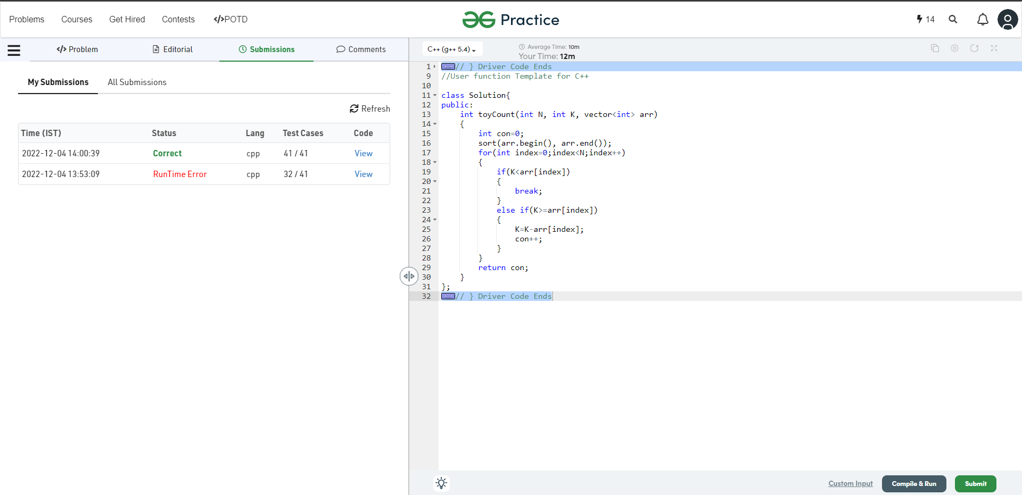

**Understanding about problem:**

* In this task I need to return number which is count of toys can buy with K amount.

Note: If you can't understand the problem, feel free to contact us and we'll help you. Please don't copy and paste from anywhere.

ALL THE BEST

Team CP Club